

**AP Calculus BC**

Q1 Interim Assessment

Test Booklet 2

Multiple Choice - Calculator

January 2017

School: ____________________________________________

Student Name: ____________________________________________

Teacher: ____________________________________________

Period: ____________________________________________

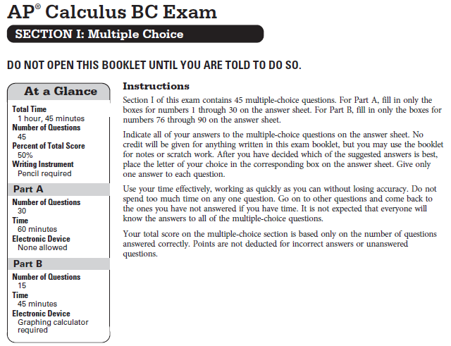

**CALCULUS BC**

**SECTION I, PART B**

**Time – 45 minutes**

**Number of questions – 15**

**A GRAPHING CALCULATOR IS REQUIRED FOR SOME QUESTIONS ON THIS PART OF THE EXAM.**

Directions: Solve each of the following problems, using the available space for scratch work. After examining the form of the choices, decided which is the best of the choices fiven and place the letter of your choice in the corresponding box on the answer sheet. No credit will be given for anything written in this exam booklet. Do not spend too much time on any one problem.

**In this exam:**

1. The exact numerical value of the correct answer does not always appears among the choices given. When this happens, select from among the choices the number that best approximates the exact numerical value.
2. Unless otherwise specified, the domain of a function $f$ is assumed to be the set of all real numbers $x$ for which $f\left(x\right)$ is a real number.
3. The inverse of a trigonometric function $f$ may be indicated by using the inverse function $f^{-1}$ or with the prefix “arc” (e.g. $\sin^{-1}{x}=\arcsin{x}$).

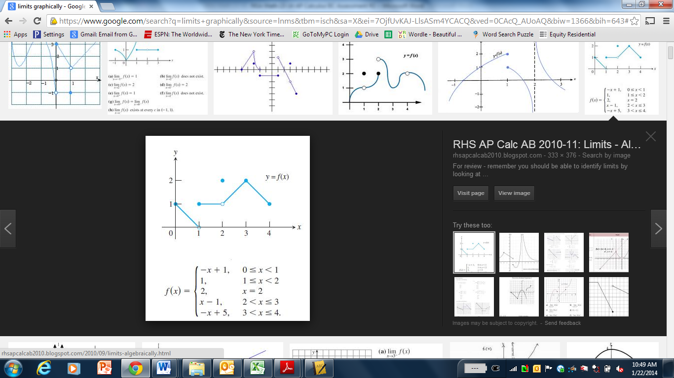

1. The graph of a function $f$ is shown above. For which of the following values of $c$ does $\lim_{x→c}{f(x)}=1$?

1. $1$ only
2. $2$ only
3. $1$ and $2$ only
4. $1, 2,$ and $3$
$$f\left(x\right)=\left\{\begin{aligned}x^{3}-4x+2 if x<-2 \\ 8x+18 if x≥-2\end{aligned}\right.$$

5. Let $f$ be the piecewise function defined above. At $x=-2$:
6. $f$ is continuous but not differentiable.
7. $f$ is differentiable but not continuous.
8. $f$ is neither continuous nor differentiable.
9. $f$ is both continuous and differentiable.
10. What is the average value of the function $f\left(x\right)=\cos{\sqrt{x}}$ on the closed interval $[1, 4]$?



$-0.161$

$0.014$

$0.041$

$0.124$

15. If $f^{'}\left(x\right)=h(x)$ and $g\left(x\right)=x^{3}$, then $\frac{d}{dx}f\left(g\left(x\right)\right)=$



$3x^{2}h(x^{3})$

$h(x^{3})$

$3x^{2}h(x)$

$x^{3}h(x^{3})$

20. At time $t=0$ years, a forest preserve has a population of 1500 deer. If the rate of growth of the population is modeled by $R\left(t\right)=2000e^{0.23t}$ deer per year, what is the population at time $t=3$?
21. 3987 (B) 5487 (C) 8641 (D) 10,141
22. Which of the following pairs of graphs could represent the graph of a function and the graph of its derivative?

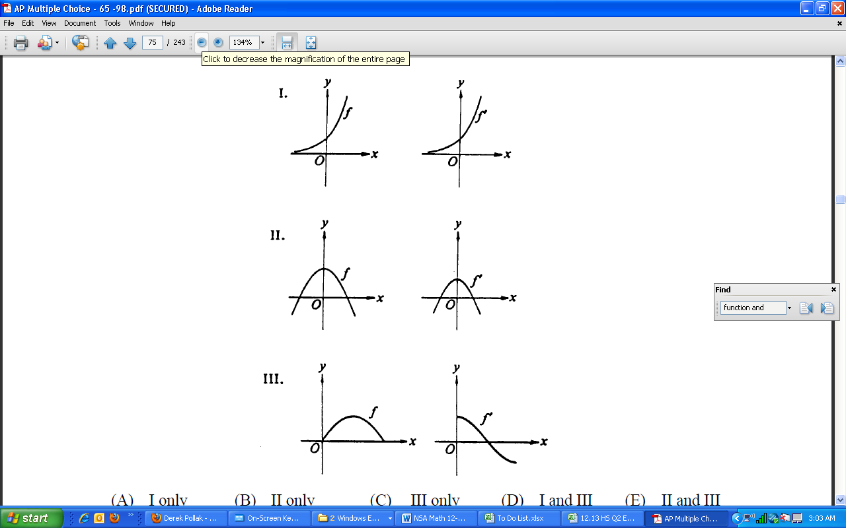

(A) I only

(B) II only

(C) III only

(D) I and III

1. A particle moves along the $x$-axis so that at time $t≥0$ its position is given by $x\left(t\right)=\cos{\sqrt{t}}$. What is the velocity of the particle at the first instance the particle is at the origin?



$-0.624$

$-0.318$

$0$

$0.065$

6. When the region bounded by the $y$-axis, $y=e^{x}$, and $y=2$ is rotated around the $y$-axis it forms a solid with volume:



$0.386$

$0.592$

$2.188$

$6.874$

11. Suppose the graph of a function $f$ is both increasing and concave up on the interval $[a, b]$. Then, using the same number of subdivisions, and with $L, R, M,$ and $T$ denoting, respectively, the left, right, midpoint, and trapezoidal sums, it follows that:



$R≤T≤M≤L$

$L≤T≤M≤R$

$R≤M≤T≤L$

$L≤M≤T≤R$

16. The slope of the line tangent to the curve $2x^{2}=y^{4}+1$ at the point $(-1, 1)$ is exactly:



$-\frac{5}{4}$

$-1$

$\frac{1}{4}$

$1$

21. The second derivative of the function $f$ is given by $f''(x)=2-3\sqrt{x}\cos^{3}{x}$. How many points of inflection does $f$ have on the interval $[0, 6]$?

$1$

$2$

$3$

$4$

|  |  |
| --- | --- |
| $$x$$ | $$f^{'}\left(x\right)$$ |
| 1 | 0.2 |
| 1.5 | 0.5 |
| 2 | 0.9 |

1. The table above gives values of $f'$, the derivative of a function $f$. If $f\left(1\right)=4$, what is the approximation to $f(2)$ obtained by using Euler’s method with a step size of 0.5?
2. 3.65
3. 4.35
4. 4.70
5. 4.80
6. Consider the function $f$ that is continuous for $-2≤x≤1$ and differentiable for $-2<x<1$. If $f\left(-2\right)=-5$ and $f\left(1\right)=4$, which of the following statements could be false?
7. There exists $c$, where $-2<c<1$, such that $f\left(c\right)=0$.
8. There exists $c$, where $-2<c<1$, such that $f'\left(c\right)=0$.
9. There exists $c$, where $-2<c<1$, such that $f'\left(c\right)=3$.
10. There exists $c$, where $-2≤c≤1$, such that $f\left(c\right)≥f(x)$ for all $x$ on the closed interval

$-2≤x≤1$.

1. Which of the following statements is always true?
2. If $f(x)$ is continuous at $x=c$, then $f'(c)$ exists.
3. If $f^{'}\left(c\right)=0$, then $f$ has a local maximum or minimum at $\left(c, f\left(c\right)\right)$.
4. If $f^{''}\left(c\right)=0$, then the graph of $f$ has an inflection point at $\left(c, f\left(c\right)\right)$.
5. If $f$ is differentiable at $x=c$, then $f$ is continuous at $x=c$.
6. A particle moves along a line so that its velocity is given by $v\left(t\right)= -t^{3}+2t^{2}+2^{-t}$ for $t≥0$. For what values of $t$ is the speed of the particle increasing?
7. $\left(0, 0.177\right)$ and $\left(1.256, ∞\right)$
8. $\left(0, 2.057\right)$ only
9. $\left(0.177, 1.256\right)$ only
10. $\left(0.177, 1.256\right)$ and $\left(2.057, ∞\right)$

**END OF SECTION I**

**IF YOU FINISH BEFORE TIME IS CALLED,**

**YOU MAY CHECK YOUR WORK ON PART B ONLY.**

**DO NOT GO ON TO SECTION II UNTIL YOU ARE TOLD TO DO SO.**